**SAVEEETHA SCHOOL OF ENGINEERING**

**CSA1142-OBJECT ORIENTED ANALYSIS AND DESIGN**

**QUESTION 17: FOOD ORDERING SYSTEM**

**USE CASE**

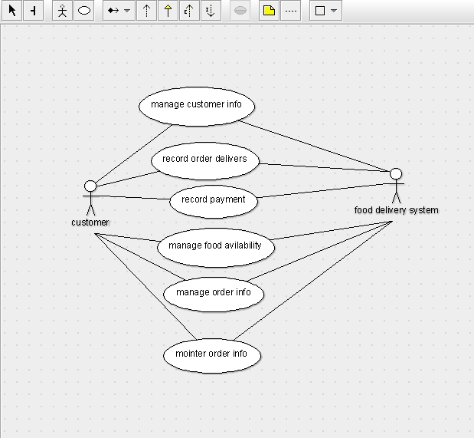

STATE DIAAGRAM

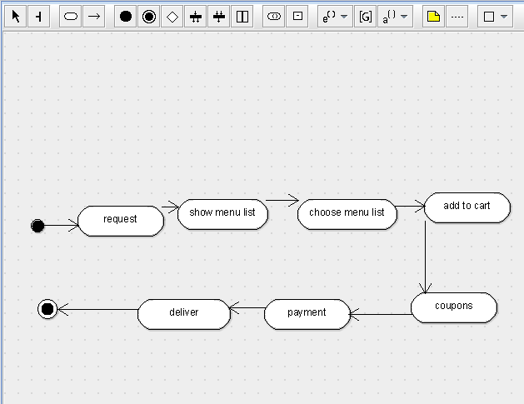

SEQUENCE DIAGRAM

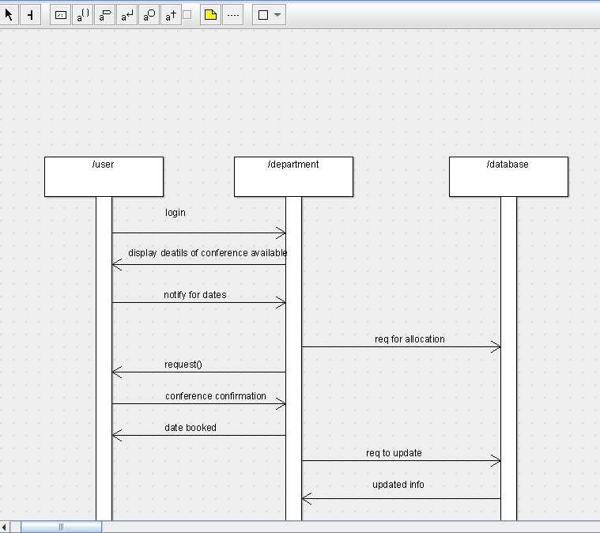

DEPLOYMENT DIAGRAM

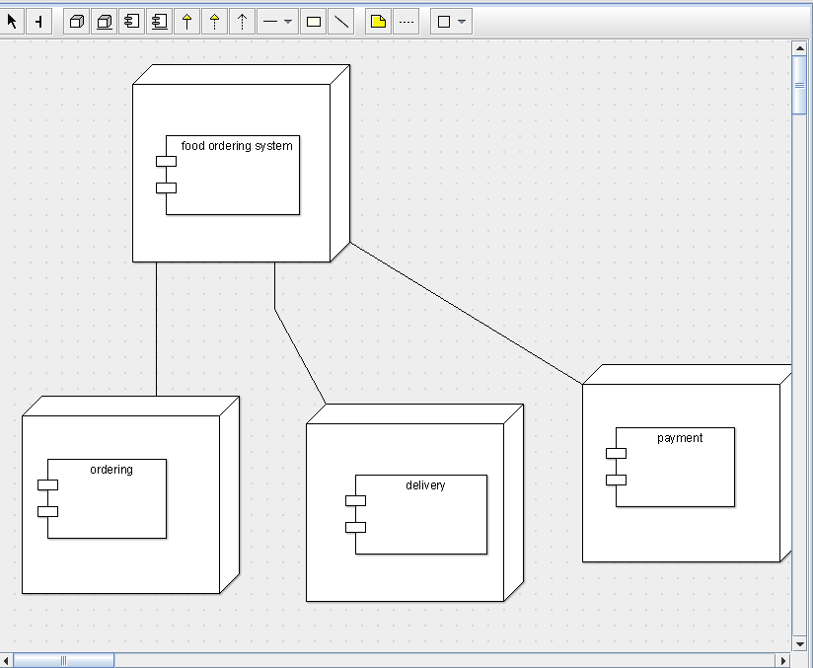

COMPONENT DIAGRAM

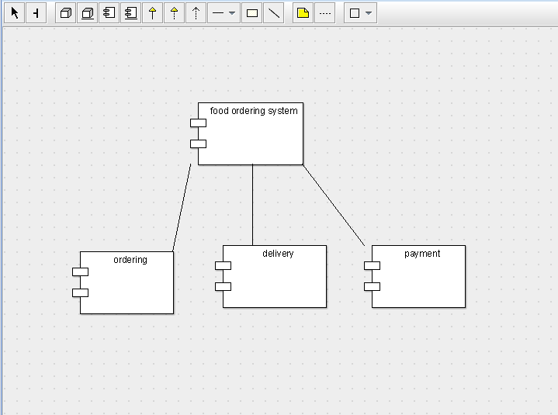

COLLABORATION DIAGRAM

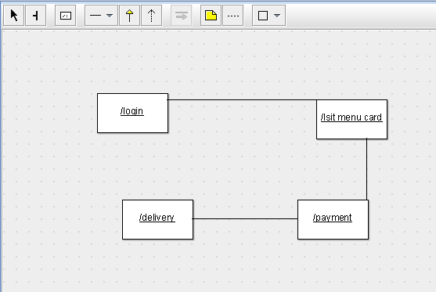

CLASS DIAGRAM

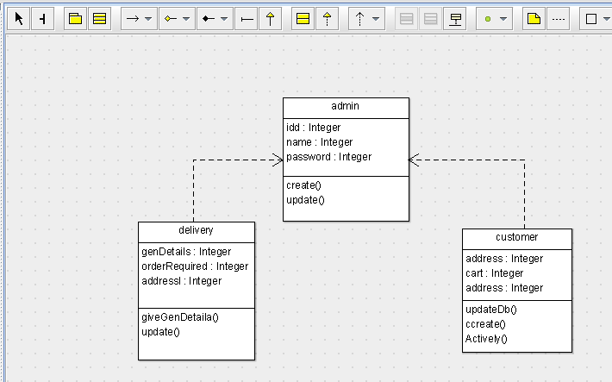

ACTIVITY DIAGRAM

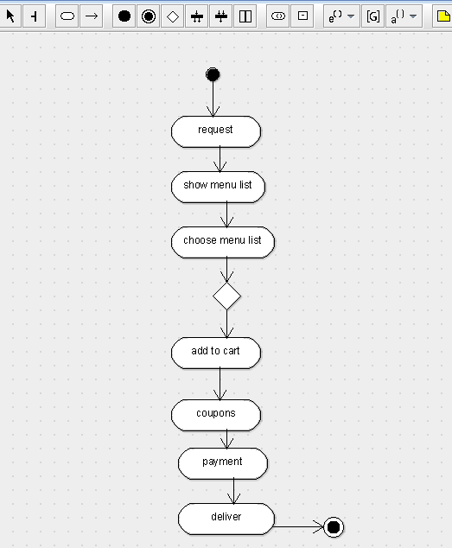

SKELETON CODE;

public class admin {

  public Integer idd;

  public Integer name;

  public Integer password;

  public void create() {

  }

  public void update() {

  }

}

public class delivery {

  public Integer genDetails;

  public Integer orderRequired;

  public Integer addressl;

  public void giveGenDetaila() {

  }

  public void update() {

  }

}

public class customer {

  public Integer address;

  public Integer cart;

  public Integer address;

  public void updateDb() {

  }

  public void ccreate() {

  }

  public void Actively() {

  }

}